Chapter 16, Solution 74.

Design a problem to help other students to better understand how to find outputs when given a transfer function and an input.

Although there are many ways to solve this problem, this is an example based on the same kind of problem asked in the third edition.

Problem

A circuit is known to have its transfer function as

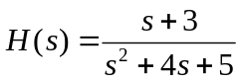

Find its output when:

(a) the input is a unit step function

(b) the input is 6te^{-2t} u(t).

Solution

- 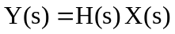

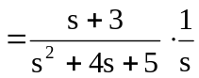
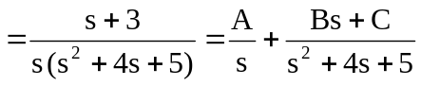

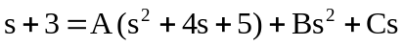

Equating coefficients :
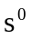: 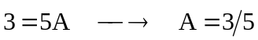
: 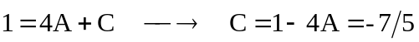
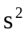: 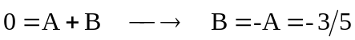

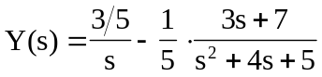
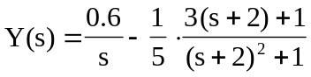

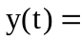

- 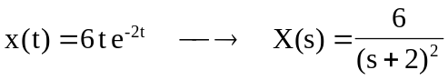

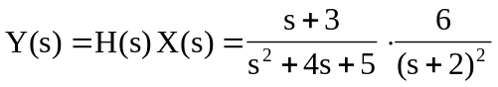
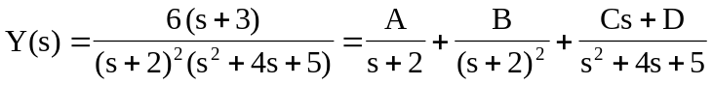

Equating coefficients :
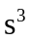: 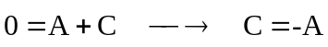 (1)
: (2)
: (3)
: (4)

Solving (1), (2), (3), and (4) gives
 